13 - Simplifying reflective practice for MBA and DBA students
Fiona McNamara¹
¹Liverpool John Moores University
The aim of this discussion paper is to suggest some alterative models and ideas which may resonate more with MBA and DBA students. This is based on my 25 years’ experience teaching reflection and my recent engagement in reflective practice as a core part of my DBA. My aim is to offer clarity on the following three areas:
- What should MBA and DBA students reflect on?
- A model to facilitate personal development.
- An alternative to reflective journalling.

Introduction.
Whilst there is no shortage of literature on reflection, many aspects of this topic remain opaque. Much of the modern dialogue and research around reflective practice comes from the domains of nursing, social work and teaching, all heavily influenced by the work of Schon (1983), with a comparative paucity of evidence from the management field (Griggs et al, 2018). Whilst there are writers on the topic from the management arena eg Reynolds and Vince (2004) their take is influenced by critical theory and focuses on reflection from an organisational perspective. Whilst important, this does not help executive MBA students looking to reflect on their leadership development, nor DBA students looking to get insights into mental blocks and personal frustrations with their research progress.

- What should MBA and DBA students reflect on?
From widespread reading I have found that much of literature on reflection does not always have much clarity on what one should reflect on. Browsing three books, by key writers on reflection, that I have to hand (Bolton and Delderfield, 2018; Fook and Gardner, 2007; Moon, 1999) and I cannot easily find the answer to this question. This is not an isolated experience. This is a vitally important question for anyone starting the process of reflection and to offer clarity on this I would like to propose three domains for reflection (Figure 1).

Figure 1: The three domains for reflection for MBA and DBA students.
The interrelated nature of the domains is illustrated by the Venn diagram circles.
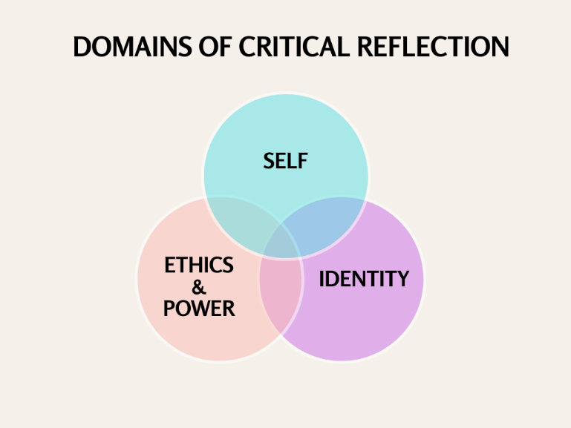
Self: the personal self. This involves thinking about hopes, dreams, wants, needs, strengths, weaknesses, personality, motivations, resilience and the importance of work life balance.
Identity –the work (or study) self. This might include considering one’s identity as a leader or as a student in which efficacy, strengths and the skills needed to progress and develop, feelings of imposterism can all be explored.
Ethics and power –the nature of the organisation in which we work and what we do. How do the existing power structures enable us to thrive or survive? What are the power and ethical issues in our work or our research and the impact of our own biases?

- A model to facilitate personal development.
The second issue is concerned with the lack of clarity in the literature around how ideas of self-awareness and self-assessment fit within the reflective practice construct. Desjarlais and Smith (2011) consider it to be separate but related, although much of the literature remains unclear on the distinction. Most of the most well-known models such as Johns (1995) and Gibbs (1988) were devised to focus on critical incident reflection in the development of professional practices. Whilst this is valuable in the medical professions, teaching and social work, as it facilitates reflection on performing medical procedures, exploring a patient or client interaction or even teaching a class, but does not align so well with the self-development element of executive leadership where the starting point does not necessarily come from exploring an incident or interaction.

Figure 2: The Bowden DEEP model.
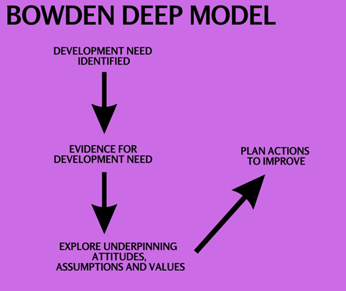
As experienced professionals MBAs and DBAs are already more primed to consider their own strengths or shortcomings and they access feedback from others in the workplace and while on their courses eg DBAs from their supervisors and MBAs from 360s (or other psychometric tests). This is not to say that reflecting on critical incidents cannot be part of this development, but to my mind it is only one part of the richness of reflective possibilities.
In 2021 I created the Bowden DEEP model (Figure 2) based on the ideas of double loop learning (Argyris, 1977) with the purpose of offering a clear structure for reflecting on self-development from various sources of feedback eg from own musings, mentors or supervisors, 360s, appraisals, performance reviews and other psychometric tools.

- An alternative to journaling
Keeping a reflective journal is the default suggested method for engaging in reflective practice (Bolton and Delderfield, 2018; Brookfield, 1998; Griggs et al 2018; Moon, 2001). From my own experiences on the DBA, it can be useful, but is time consuming and generates so much unwieldy detail that it is difficult to unpack and make sense of. Various research has identified time as the main barrier to engaging in reflection (Finlay, 2008; Gibbs et al, 2018).
As an alternative, photo-voice (Wang and Burris, 1997), used as a qualitative research methodology to explore underpinning narratives, works just as well as a reflective tool. Using photographs and images as a way of gaining deeper self-insights and unlocking previously unexplored self-schemas. There are several protocols used to unpack the learning from photovoice narratives eg Horwitz (2012) PHOTO protocols.
Figure 3: The WHAT protocols for using creative reflective techniques
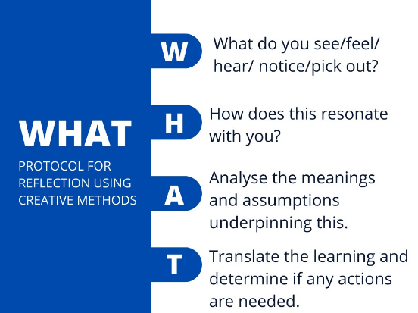
I have adapted this to something that better facilitates sensemaking in the reflective practice domain and used the acronym WHAT (Figure 3). The word ‘what’ has an interrogative meaning and asks us to question the meaning, identity or proposition, value of something, which is at the heart of self-reflection.
To use the WHAT technique requires the selection of a photograph or image (this can be applied to music, sounds, poetry, memes, artefacts, dérive walks) and the participant works their way through the WHAT protocol questions. This can be a free association with whatever comes to mind, or reflections can be on a particular theme eg confidence.
Conclusion
Finlay summarised the difficulties of reflection ‘The problem with reflective practice is that it is hard to do and equally hard to teach. It is even harder to do and teach effectively’. (2008 p 15). This is even more complex in the management and business domain and especially at the executive level of MBA and DBA students. I would like to hope that my ideas and suggestions could add some clarity to the existent body of writing on the topic.

References:
Argyris, C. (1977) Double Loop learning in Organisations. Harvard Business Review Sept 1977.
Bolton, G., and Delderfield, R. (2018) Reflective Practice: writing and Professional Development. 5th Edition, Sage.
Desjarlais, M., and Smith, P. (2011) A Comparative Analysis of Reflection and Self-Assessment. International Journal of Process Education (June 2011, Vol 3 Issue 1).
Finlay, L. (2008) Reflecting on Reflective Practice. A discussion paper for Practice Based Professional Learning Centre, paper 52, The Open University.
Fook, J., and Gardner, F. (2007) Practicing Critical Reflection: A Resource Handbook. Open University Press, McGraw Hill Education.
Gibbs, G. (1988) Learning by Doing: A guide to teaching and learning methods. Further Education Unit. Oxford Polytechnic: Oxford
Griggs, V., Lawless, A., Rae, J., and Holden, R. (2018) From reflective learning to reflective practice: assessing transfer. Studies in Higher Education, 43 (7), pp.1172-1183.
Horwitz, J. (2012) Photovoice as a critical reflection methodology. Agency through teacher education: Reflection, community, and learning, pp.15-24.
Johns, C. (1995) Framing learning through reflection within Carper’s fundamental ways of knowing in nursing. Journal of Advanced Nursing. 22, 2, 226-234
Moon, J. (1999) Reflection in Learning and Professional Development: theory and practice. Routledge Falmer.
Reynolds, M., and Vince, R. (2004). Organizing reflection: An introduction. Organizing reflection, pp.1-14.
Schon, D., A. (1983) The reflective practitioner: How professionals think in action. New York: Basic Books.
Wang, C., and Burris, M., A. (1997). Photovoice: Concept, methodology, and use for participatory needs assessment. Health education & behavior, 24(3), pp.369-387.

